QUEUEWATCH SA
Comprehensive Full-Stack Technical Architecture & Software Design Documentation

Module: DSW02A1 — Advanced Web Development
Institution: University of Johannesburg (UJ)
Development Squad: Dev Squad (DSW02A1, Team 2)
Maintained By:
Shanita-Mimsiima Mugimbi (221049640)
Date: June 2026

Table of Contents
2. Project Overview 3
3. Functional & Non-Functional Requirements 3
3.1 Functional Requirements 3
3.2 Non-Functional Requirements 3
4. User Roles 4
5. Permissions Matrix 4
6. Use Cases 5
7. Process Flow 6
8. Sequence Diagram 7
9. UML Class Diagram 8
10. System Architecture 8
11. Navigation Structure 8
12. API Requirements 9
12.1 Authentication Framework /api/auth 9
12.2 Public Telemetry Entities /api/branches 10
12.3 Crowd Reports Pipeline /api/reports 10
13. Design Justification 11
14. Solution Design 12
14.1 Complete Database Tables Mapping Schema 12
14.2 Physical File Distribution & Folder Map Tree 12
15. Figma (Prototype) Fully Functional 13
16. Main Streams 13
17. User Interface Must Be User-Friendly 14
18. User Experience Flow 14
19. Clickable Interaction 14

2. Project Overview
QueueWatch SA is a full-stack, community-driven queue-reporting and monitoring web application explicitly customized for South African public service offices (including the Department of Home Affairs, SASSA, community clinics, and road traffic licensing departments). Long queues and extended waiting times represent major structural bottlenecks within South African civic infrastructure, often resulting in lost productivity and severe public frustration. QueueWatch SA resolves this issue by empowering citizens who are physically present inside a branch to update and publish live queue conditions (e.g., status classification and estimated waiting intervals) directly onto an open database.
By crowdsourcing real-time service conditions, the application provides a transparent tracking utility that enables other community members to make well-informed decisions regarding when it is optimal to visit a specific branch. The platform emphasizes structural simplicity, rapid loading capability, zero commercial tracking dependencies, and mobile responsiveness via a customized dark user interface theme designed to mirror structural dashboard system configurations.

3. Functional & Non-Functional Requirements

3.1 Functional Requirements
- Branch Discovery & Navigation: Citizens must be able to view an expansive collection of registered public service branch locations in Gauteng filtered dynamically by regional branch types and operational crowd levels.
- Real-Time Crowdsourced Status Panel: Provides an internal custom-developed sub-panel that displays global service indicators, sorting facilities into categories of 'Quiet', 'Busy', 'Very Busy', or 'System Offline'.
- Queue Report Submission Form: Authenticated users can transmit active reports outlining wait minutes, structural queues status, and contextual notes.
- Live Aggregated Branch Profiles: Incorporates an automated algorithmic evaluation of a specific branch to update structural statistics metrics (average delay, peak operational times, total submittals).
- Automated Bot Prevention (CAPTCHA): Protects registration and contact panels against automated malicious submittals utilizing an asynchronous alphanumeric inline SVG CAPTCHA generator.
- User Profile & Personal Submission Feed: Facilitates account monitoring, full tracking history, error rate calculations, and configuration of security profiles.
- Admin Moderation Hub: Grants global access control permitting structural deletion or administrative flagging of misleading reporting indicators.
- Civic Engagement Mini-Game: To keep users engaged while standing in long queues, a fully functional client-side Tic-Tac-Toe mini-game is embedded beneath the main dashboard.

3.2 Non-Functional Requirements
- Visual Usability (Theme Adaptability): The user interface must employ deep background tones paired with high-contrast elements, compliant with WCAG AAA structural readability specifications under poor sunlight conditions.
- Performance & Speed Constraints: Application response times for data fetching requests must not exceed 2.5 seconds on active mobile data connections.
- Cryptographic Data Protection: User credentials must be cryptographically protected using the blowfish-backed bcryptjs engine configured with a computational work factor index of 10.
- System Security & Session Integrity: Access to administrative routing blocks must be verified at the data transaction layer via server-side session guards to prevent vertical privilege escalation.
- Framework Independence: The technical build must depend on vanilla web technologies, omitting heavy frameworks to ensure optimal performance on low-tier consumer smartphones.

4. User Roles
The application defines three specific actor categories with strict operational bounds:
- Unauthenticated Public Guest: Anonymous web consumers who can access the landing page, explore public office listings, adjust dynamic filters, and observe historical feeds. They cannot submit reports or view profile views.
- Registered Community Member (User Role): Verified community members possessing an active, authenticated system session. They enjoy all guest rights, can transmit queue reports, track active personal history, and modify profile account data.
- System Administrator (Admin Role): High-privilege operators managing overall data compliance. They look over system analytics, access the full report stream, flag erroneous metrics, and execute hard record deletions.

5. Permissions Matrix
The following matrix maps user roles to application actions:
Functional Endpoint / Action | Public Guest | Registered User | System Admin
Browse Branches & Apply Search Filters | ALLOWED | ALLOWED | ALLOWED
Inspect Individual Branch Timeline Feed | ALLOWED | ALLOWED | ALLOWED
Play Queue Tic-Tac-Toe Mini-Game | ALLOWED | ALLOWED | ALLOWED
Register Account & Resolve Captcha | ALLOWED | ALLOWED | DENIED (Implicit)
Submit New Real-Time Queue Report | DENIED (Redirect) | ALLOWED | ALLOWED
Access User Dashboard & Settings | DENIED (Redirect) | ALLOWED | ALLOWED
View Comprehensive Global Analytics | DENIED (401) | DENIED (401) | ALLOWED
Flag / Mark Report as Questionable | DENIED (401) | DENIED (401) | ALLOWED
Hard Delete Malicious Queue Reports | DENIED (401) | DENIED (401) | ALLOWED

6. Use Cases
Use Case 1: Dynamic Branch Analysis & Verification
- Primary Actor:Citizens seeking public facility wait profiles.
- Goal:The actor filters regional facilities on the platform to verify if their intended destination is heavily congested.
- Flow of Events:1. Actor opens the application and clicks on the 'Browse Branches' catalog.
2. System extracts data structures via GET /api/branches and returns records.
3. Actor chooses 'Home Affairs' from the type dropdown and inputs text string 'Soweto'.
4. Interface parses metadata variables and re-renders matching branch cards.
5. Actor reviews the status label ('Very Busy' - 140 min average delay) and decides to stay home.
Use Case 2: Verification and Submission of Live Queue Report
- Primary Actor:Registered Community Member.
- Goal:To publish active crowd conditions at a specific branch.
- Flow of Events:1. Actor accesses branch.html and hits '+ Add Report'.
2. Script executes auth check validation via GET /api/auth/me.
3. The platform reveals the submittal structure, auto-selecting the specific facility identifier.
4. Actor sets status designation to 'Busy', inputs '45' for wait minutes, and clicks submit.
5. Backend processes the payload via POST /api/reports, stores the record, and displays a success toast.
Use Case 3: Admin Moderation & Record Removal
- Primary Actor:System Administrator.
- Goal:To purge malicious data and clean the reporting metrics.
- Flow of Events:1. Administrator logs into admin.html.
2. Dashboard extracts metrics from /api/reports and highlights a report flagged for trolling.
3. Administrator presses the 'Remove' toggle.
4. Endpoint handles transaction via DELETE /api/reports/:id.
5. System confirms deletion, removes the item from the data view, and recalculates live statistics.

7. Process Flow
The application's core logic governs how incoming telemetry loops update public listings and handle user navigation:
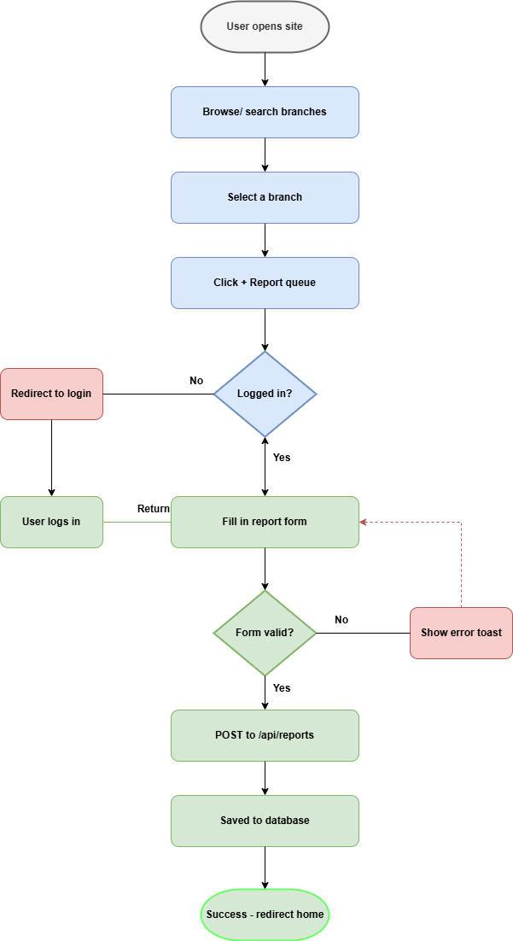

8. Sequence Diagram
This text-based sequence diagram traces the complete network transaction lifecycle during a new report submission:
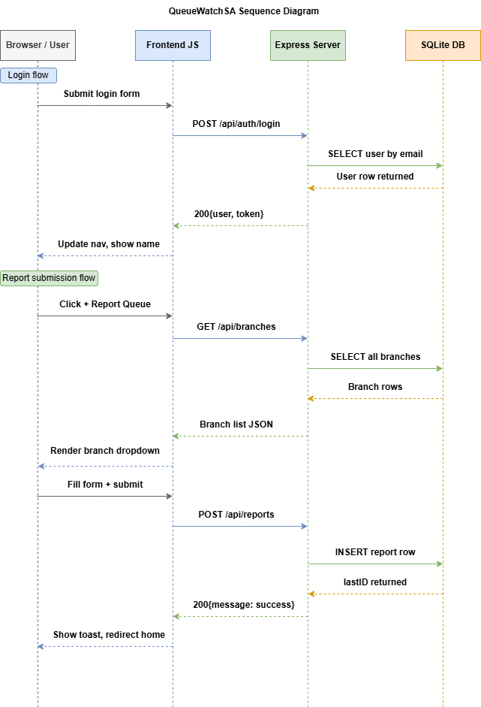

9. UML Class Diagram
The underlying logic utilizes structural entity associations outlined below via relational entity fields:
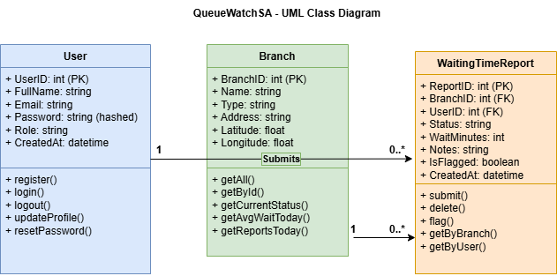

10. System Architecture
QueueWatch SA uses a layered client-server architecture deployed on Render.com:
- Client Presentation Layer (Frontend): High-contrast static layouts constructed in pure HTML5, layout rules in CSS3, and application flow managed via vanilla ES6 Javascript. No single-page framework overhead is introduced.
- Application Logic Gateway (Backend): Node.js engine running an Express.js server instance. Governs session states, route bindings, validation checks, and secure JSON delivery headers.
- Data Storage Subsystem (Database): Structured SQLite transactional engine running local persistent storage tables. Status aggregations are resolved dynamically on-demand using performant SQL subqueries.
- External Messaging Framework: Interfaced directly with the Brevo HTTP API via secure network requests to deliver transactional registration messages, completely bypassing Render's outbound SMTP blocks.

11. Navigation Structure
The navigation tree adapts fluidly across 11 discrete paths based on user authorization profiles:
- Universal Content Route Tree: index.html (Landing Hub) ──► branches.html (Advanced Multi-Filter) ──► branch.html (Detailed Insights & Timeline Feed) ──► about.html (Mission Context) ──► contact.html (Inquiries Panel).
- Authenticated Member Progression View: If Unauthenticated ──► Shows Login/Register Tabs on auth.html. After authorization, user session state unlocks profile.html (History Log & Profile Controls) and report.html (Submission Panel).
- Administrative Control Isolation: If Admin ──► Global nav shifts exclusively to admin.html, hiding general consumer panels to secure management workflows.

12. API Requirements

12.1 Authentication Framework /api/auth
Method | Endpoint | Auth Required | Operational Purpose
POST | /register | No | Registers a user. Requires password validation and server-side CAPTCHA verification.
POST | /login | No | Verifies credentials via bcrypt and creates an express-session instance.
POST | /logout | Yes | Destroys the current user session and clears authentication cookies.
GET | /me | Yes | Returns active session variables or triggers a 401 unauthenticated response.
PUT | /profile | Yes | Modifies account metadata and optionally updates user security passwords.
POST | /forgot-password | No | Generates a base64 account token and dispatches a reset link via Brevo.
POST | /reset-password | No | Decodes the incoming URL token and updates database password rows.
POST | /contact | No | Validates a contact form submission and forwards an inquiry email to the admin.
GET | /captcha | No | Generates an alphanumeric SVG string image and stores the answer in the session.

12.2 Public Telemetry Entities /api/branches
Method | Endpoint | Auth Required | Operational Purpose
GET | / | No | Returns all branches augmented with live SQL-calculated metrics (avg wait, crowd status, total logs).
GET | /:id | No | Extracts a single branch location profile based on its unique integer key value.

12.3 Crowd Reports Pipeline /api/reports
Method | Endpoint | Auth Required | Operational Purpose
GET | /branch/:id | No | Fetches all reports linked to a branch ID, ordered newest first with usernames joined.
GET | /user | User Role | Extracts all submittals authored by the logged-in user for accuracy calculations.
GET | /stats | Admin Role | Returns a high-level JSON summary object displaying total users and branches.
GET | / | Admin Role | Returns all reports in the database for admin page dashboard visualization.
POST | / | User Role | Commits a new queue status entry to the database. Requires branch ID and crowd status fields.
DELETE | /:id | Admin Role | Hard-deletes an erroneous report row from the database using its unique index key.
PATCH | /:id/flag | Admin Role | Updates a report row setting IsFlagged=1 to mark it as suspicious without deletion.

13. Design Justification
- System Dark Theme Choice: Tailored with dark surface elements to accommodate users standing inside public spaces where glare is a major accessibility blocker.
- Accent Token Selections: High contrast primary colors (Yellow #F5C518) provide clear visual landmarks on budget mobile displays.
- Typographic Selection Criteria: Employs the distinct 'Syne' font for system headers to establish a modern identity, paired with 'Space Mono' for data listings to present analytical numbers clearly.
- Vanilla Development Architecture: Eliminating client framework runtimes (React/Vue) allows pages to render instantly, minimizing mobile data costs for resource-constrained community members.

14. Solution Design

14.1 Complete Database Tables Mapping Schema
Table Structures Overview
1. Table: Users
- UserID (INTEGER, Primary Key, Autoincrement)
- FullName (TEXT, Not Null)
- Email (TEXT, Not Null, Unique Unique Constraint)
- Password (TEXT, Not Null — Holds Bcrypt Cryptographic Hashes)
- Role (TEXT, Default value set to 'user')
- CreatedAt (DATETIME, Defaulting to Current Timestamp)
2. Table: Branches
- BranchID (INTEGER, Primary Key, Autoincrement)
- Name (TEXT, Not Null)
- Type (TEXT, Not Null: 'Home Affairs' | 'SASSA' | 'Clinic' | 'Licensing')
- Address (TEXT)
- Latitude (REAL)
- Longitude (REAL)
- CreatedAt (DATETIME, Defaulting to Current Timestamp)
3. Table: WaitingTimeReports
- ReportID (INTEGER, Primary Key, Autoincrement)
- BranchID (INTEGER, Not Null, References Branches table)
- UserID (INTEGER, Not Null, References Users table)
- Status (TEXT, Not Null: 'Quiet' | 'Busy' | 'Very Busy' | 'System Offline')
- WaitMinutes (INTEGER, Default value 0)
- Notes (TEXT, Optional open text field)
- IsFlagged (INTEGER, Default value 0 — Binary boolean indicator for admin flagging)
- CreatedAt (DATETIME, Defaulting to Current Timestamp)

14.2 Physical File Distribution & Folder Map Tree
/ (Project Root Directory)
├── .env ← Stores session secrets, Brevo HTTP API keys, port allocations
├── .gitignore ← Prevents checking in database.sqlite file, local nodes module modules
├── package.json ← Configuration for scripts starting backend pipeline via subfolders
├── public/ ← Houses static client assets served by logic systems
│ ├── css/
│ │ └── style.css ← Central shared stylesheet managing application aesthetics
│ ├── js/
│ │ ├── script.js ← Coordinates real-time branch data processing and filter actions
│ │ ├── nav-auth.js ← Adjusts header layouts based on session storage states
│ │ └── profile.js ← Powers account settings tracking views
│ ├── index.html ← Landing hub housing metrics tiles and queue Tic-Tac-Toe minigame
│ ├── branches.html ← Displays the complete branch matrix equipped with advanced filter panels
│ ├── branch.html ← Detail interface with chronological feeds and maps context grids
│ ├── auth.html ← Unified interface managing registration and user logins
│ ├── reset.html ← Account password restoration layout using base64 tokens
│ ├── report.html ← Authenticated panel for transmitting fresh queue report metrics
│ └── admin.html ← Administration moderation layout for flag operations
└── server/
├── server.js ← Base Express server mounting routing modules and session rules
├── db.js ← Controls SQLite engine setups and structural seed files
└── routes/
├── auth.js ← Manages registration logic and CAPTCHA rendering
├── branches.js ← Read-only API delivering real-time computed branch telemetry
└── reports.js ← Governs report processing and admin moderation lines

15. Figma (Prototype) Fully Functional
The visual user interface architecture was fully structured in Figma prior to physical implementation. It models exact operational views including reactive component state definitions, element hierarchies, and viewport breakpoints across mobile and desktop platforms.
★ FIGMA SCREENSHOT PLACEHOLDER: Please insert the exported UI prototype screenshots here. The prototype mapping covers all 11 user states including user login pages, active multi-dropdown configurations, report forms with preset inputs, and administration tables featuring row removal buttons.

16. Main Streams
The application operates across three fundamental data processing and transaction streams:
- The Public Telemetry Consumption Stream: Unauthenticated request for branches -> API aggregates rows via complex subqueries -> Javascript formats numerical data objects -> Cards update instantly inside the DOM grid layout view.
- The Crowdsourced Reporting Submission Stream: User triggers report submission -> Javascript checks credentials status -> Form content converts to a JSON payload -> Express handles field validation -> Transaction commits to SQLite file.
- The Data Moderation & Compliance Stream: Admin logs onto system panel -> Backend validates session variables -> System surfaces all reporting data -> Operator hits deletion control -> Row is purged, and statistics recalculate immediately.

17. User Interface Must Be User-Friendly
The system design adheres strictly to the following visual usability principles to ensure accessible operation for all South African citizens:
- High-Contrast Status Badging: Visual indicators update their color state instantly according to current queue density: Green indicates 'Quiet' conditions, Orange indicates 'Busy', Red-Orange alerts to 'Very Busy' lines, and Slate Grey denotes system failures.
- Thumb-Optimized Target Zones: All interactive buttons and input controls feature a touch target size of at least 44x44 points, ensuring easy selection on low-cost smartphones with unstable displays.
- Simplified Time Context: Long timestamps convert automatically into relative text labels (e.g., '5 mins ago') using client-side formatting logic, removing cognitive friction for users evaluating information relevance.
- Layout-Stabilized Load Indicators: Network loading events display an animated pulsing skeleton layout block matching the exact dimensions of incoming branch cards, eliminating layout shift and providing immediate system feedback.

18. User Experience Flow
The citizen journey is designed to minimize interactions, allowing users to find critical queue information in under three taps:
- Tap 1 (Discovery): Consumer arrives on index.html, checks the global statistics counter summary bar, and immediately sees current service metrics without navigating off the landing page.
- Tap 2 (Target Isolation): Consumer opens the advanced search dropdown filters on branches.html, filtering listings down to nearby offices instantly via dynamic client-side filtering.
- Tap 3 (Verification Summary): Consumer clicks an operational office card, opening branch.html to view active timelines, crowd logs, and location context grids.

19. Clickable Interaction
The system features highly responsive client-side visual interactions to deliver immediate feedback when elements are selected:
- Asynchronous Filter Switchers: Tab headers swap visual states instantly on selection by adjusting CSS class labels, filtering display grids smoothly without triggering full-page web reloads.
- Contextual Data Forwarding: Pressing '+ Add Report' dynamically reads the active branch identifier object from local storage, pre-populating the target input dropdown automatically to avoid user error.
- Non-Blocking Toast System Alerts: Form submissions trigger an animated toast notification box that slides out from the side margins, giving clear feedback before executing page changes.
- Instant-Response Mini-Game Inputs: The embedded Tic-Tac-Toe mini-game handles grid selection updates completely locally, providing an instant distraction for users waiting in physical public office queues.

